**A Report**

On

**GLOBAL SUPERSTORE**

**Submitted in partial fulfillment of the requirements for the award of degree of**

**BACHELOR OF TECHNOLOGY**

**in**

**COMPUTER SCIENCE & ENGINEERING**

**BY**

**22WH1A05B1 – B. Greesma**

**Under the esteemed guidance of**

**Dr. G. Naga Satish**

**Professor**



**Department of Computer Science & Engineering**

BVRIT HYDERABAD

COLLEGE OF ENGINEERING FOR WOMEN

**(NBA Accredited EEE.ECE.CSE.IT B.Tech Courses)**

**(Approved by AICTE, New Delhi and Affiliated to JNTUH, Hyderabad)**

**Bachupally, Hyderabad – 500090**

**2023-2024**

BVRIT HYDERABAD

COLLEGE OF ENGINEERING FOR WOMEN

**(NBA Accredited EEE.ECE.CSE.IT B.Tech Courses)**

**(Approved by AICTE, New Delhi and Affiliated to JNTUH, Hyderabad)**

**Bachupally, Hyderabad – 500090**

Department of Computer Science & Engineering



**CERTIFICATE**

This is to certify that the entitled “ **________Global Superstore_______**” is a bonafide work carried out by **_____22WH1A05B1_____** in partial fulfillment for the award of B.Tech degree in  **Computer Science & Engineering** , **BVRIT HYDERABAD College of Engineering for Women, Bachupally, Hyderabad**, affiliated to Jawaharlal Nehru Technological University Hyderabad, Hyderabad under my guidance and supervision. The results embodied in the work have not been submitted to any other University or Institute for the award of any degree or diploma.

**Internal Guide Head of the Department**

**Dr. G. Naga Satish Dr. Sreevani Madduri**

**Professor, CSE Professor, CSE**

**External Examiner**

**DECLARATION**

We hereby declare that the work presented entitled **“_____Global Superstore_____”** submitted towards completion of Lab Activities in II Year of B.Tech of CSE at **BVRIT HYDERABAD College of Engineering for Women,** Hyderabad is an authentic record of our original work carried out under the guidance of **Dr. G. Naga Satish, Professor, Department of CSE.**

Sign with Date:

**ACKNOWLEDGEMENT**

We would like to express our sincere thanks to **Dr. K. V. N. Sunitha**, **Principal, BVRIT HYDERABAD College of Engineering for Women,** for her support by providing the working facilities in the college.

We are extremely thankful to our Internal Guide, **Dr. G. Naga Satish, Professor, CSE, BVRIT HYDERABAD College of Engineering for Women,** for his constant guidance and encouragement throughout the project.

Finally, we would like to thank all Faculty and Staff of CSE department who helped us directly or indirectly. Last but not least, we wish to acknowledge our **Parents** and **Friends** for giving moral strength and constant encouragement.

**ABSTRACT**

The Global Superstore dataset is a comprehensive and diverse collection of retail data that spans various regions, product categories, and time periods. This dataset provides a rich resource for analyzing global supply chain dynamics, customer behavior, and business performance in the retail sector. With information on sales, profits, shipping details, and customer demographics, the dataset enables researchers and analysts to explore patterns, trends, and key drivers influencing the success of a global superstore.

The abstract for the Global Superstore dataset could highlight its significance in understanding the complexities of operating a retail business on a global scale. It may emphasize the dataset's potential for uncovering insights into market demand, inventory management, and customer preferences. Additionally, the abstract could touch upon the dataset's applicability in developing data-driven strategies to optimize supply chain operations, enhance customer satisfaction, and improve overall business profitability for global superstores. Overall, the Global Superstore dataset abstract would convey its value as a valuable resource for academic research, business analytics, and decision-making in the retail industry.

**INTRODUCTION**

The Global Superstore dataset stands as a pivotal resource in the realm of retail analytics, offering a comprehensive and intricate glimpse into the operations of a vast international retail network. As a conglomerate of data encompassing various geographical regions, an extensive array of product categories, and a diverse timeframe, this dataset serves as an invaluable tool for researchers, analysts, and business leaders seeking to unravel the complexities inherent in managing a global superstore.

In an era marked by increasingly interconnected markets and complex supply chains, understanding the dynamics of a global retail enterprise is paramount. The Global Superstore dataset not only provides a wealth of information on sales figures and profits but also delves into crucial aspects such as shipping logistics, customer demographics, and product details. This multifaceted dataset opens avenues for exploration, enabling a nuanced examination of patterns, trends, and critical drivers that shape the success of a retail giant operating on an international scale.

This introduction sets the stage for a deeper exploration of the dataset's significance in uncovering insights into global supply chain dynamics, consumer behavior, and overall business performance within the retail sector. As we delve into the layers of this dataset, we aim to glean actionable intelligence that can inform strategic decision-making, optimize supply chain operations, and enhance the overall competitiveness and sustainability of global superstores in a dynamic and ever-evolving marketplace.

|  |  |  |
| --- | --- | --- |
| S.No. | Description | Page No. |
| 1 | Tableau | 9-20 |
| 2 | Power BI | 22-23 |
| 3 | Looker Studio | 24-25 |

|  |  |  |
| --- | --- | --- |
| S. No | Name of the Experiment | Page Number |
| **Perform the Following Using Tableau** | | |
| 1 | Creating Your First visualization of the Data Set and also print the Data Source? | 9 |
| 2 | Connecting your Data and create basic charts(line, bar charts, Tree maps), Using the Show me panel. | 9-11 |
| 3 | Perform the Calculations like Overview of SUM, AVR, and Aggregate features, Creating custom calculations and fields. | 11-12 |
| 4 | Applying new data calculations to your visualizations, Formatting Visualizations, Formatting Tools and Menus, Formatting specific parts of the view. | 12-13 |
| 5 | Editing and Formatting Axes, Manipulating Data, Pivoting data. | 13-14 |
| 6 | Structuring your data, Sorting and filtering data, Pivoting data. | 14 |
| 7 | Using Filters, Using the Detail panel, using the Size panels, customizing filters, Using and Customizing tooltips, Formatting your data with colors. | 15-16 |
| 8 | Creating Dashboards & Storytelling, creating your first dashboard and Story, Design for different displays, adding interactivity to your Dashboard, Distributing & Publishing your Visualization. | 17-18 |
| 9 | Creating custom charts, cyclical data and circular area charts, Dual Axis charts. | 18-22 |
| **Perform Using Power BI** | | |
| 1 | Connecting your Data and create basic charts(line, bar charts, Tree maps), Using the Show me panel. | 22-23 |
| **Perform Using Looker Studio** | | |
| 1 | Connecting your Data and create basic charts(line, bar charts, Tree maps), Using the Show me panel. | 24-25 |
| 2 | Perform the Calculations like Overview of SUM, AVR, and Aggregate features, Creating custom calculations and fields. |
| 3 | Creating Dashboards |
| 4 | Using Filters, |

**TABLEAU**

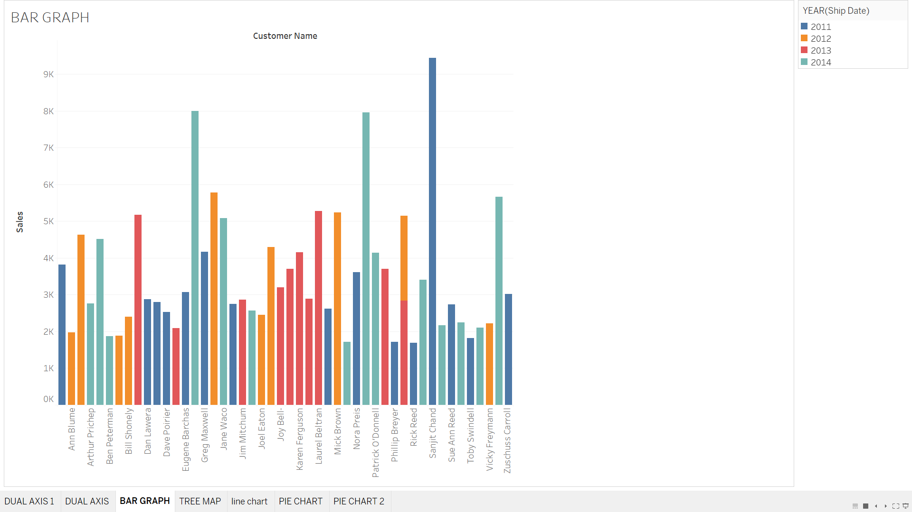

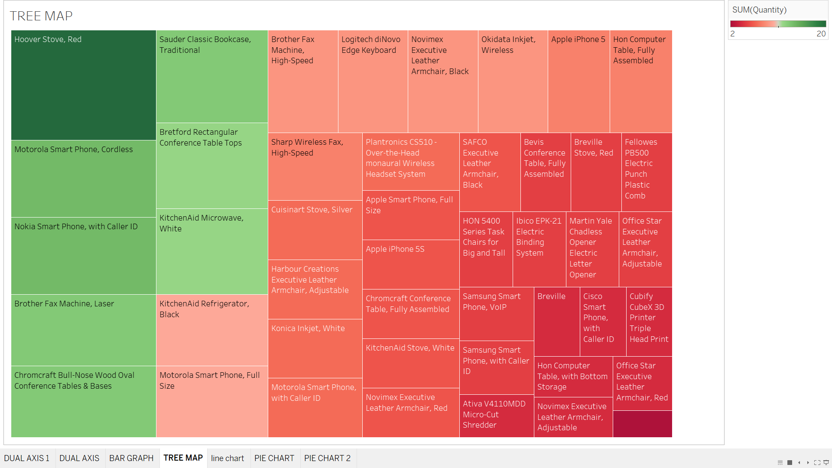

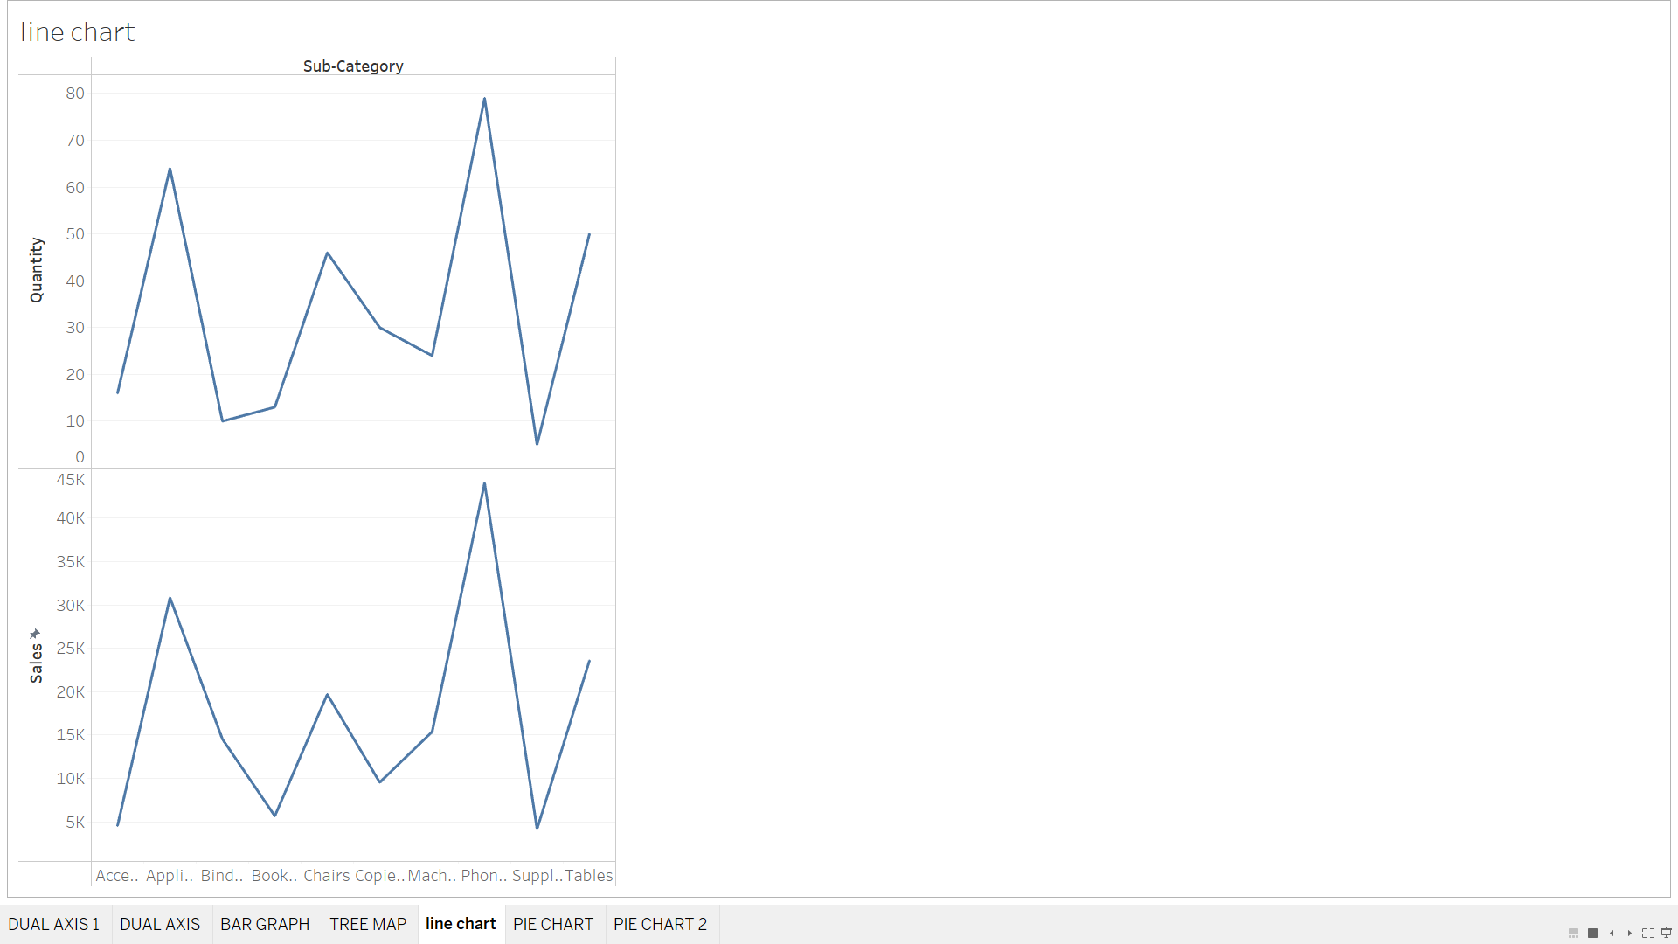

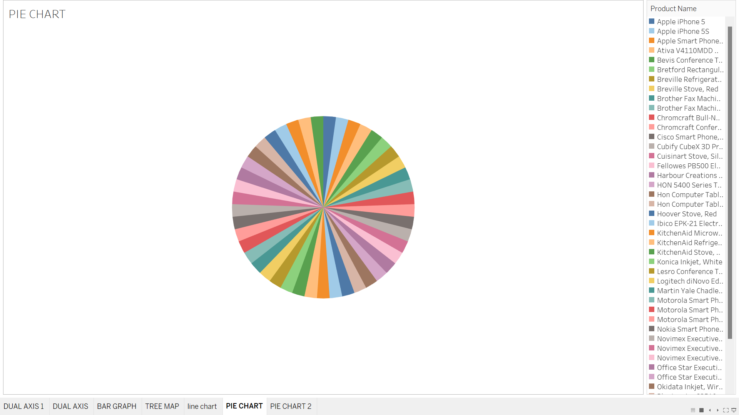

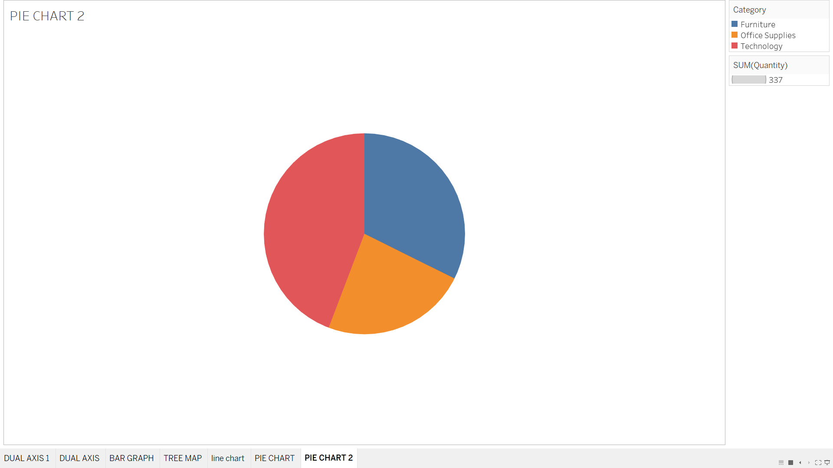

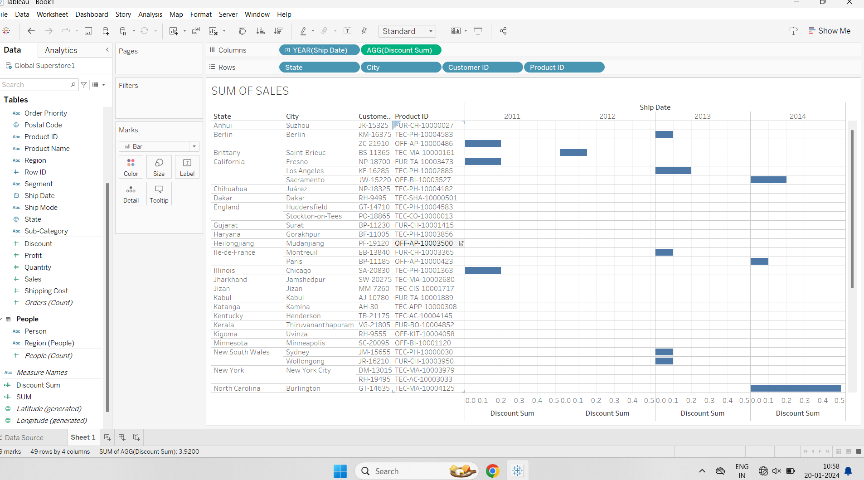

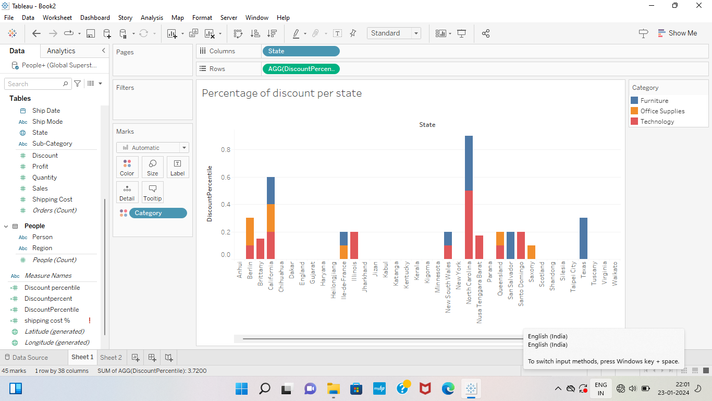

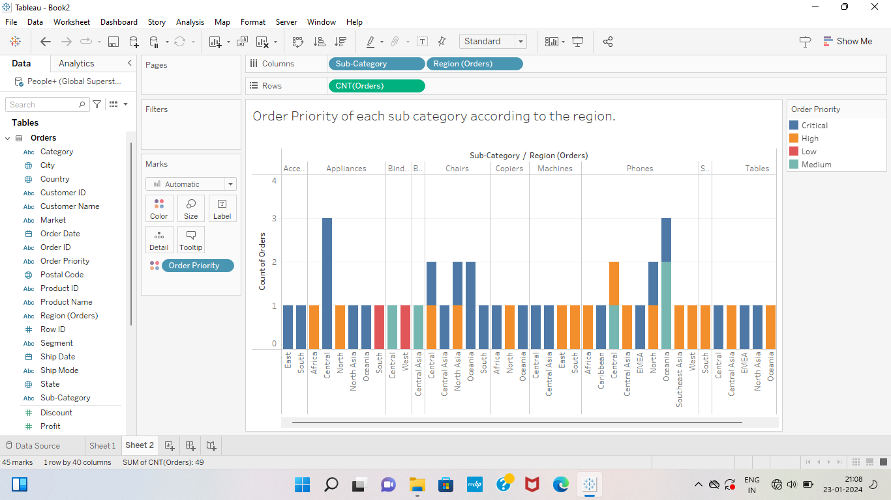

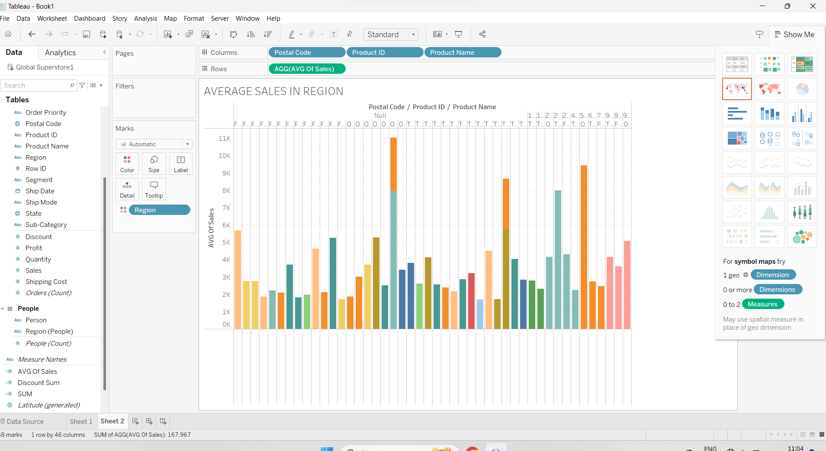

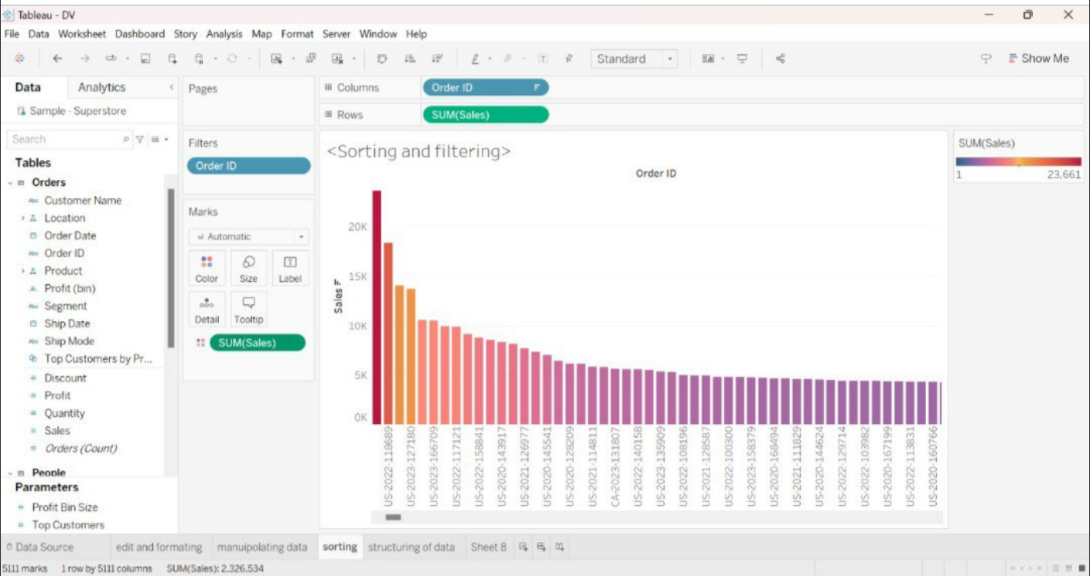

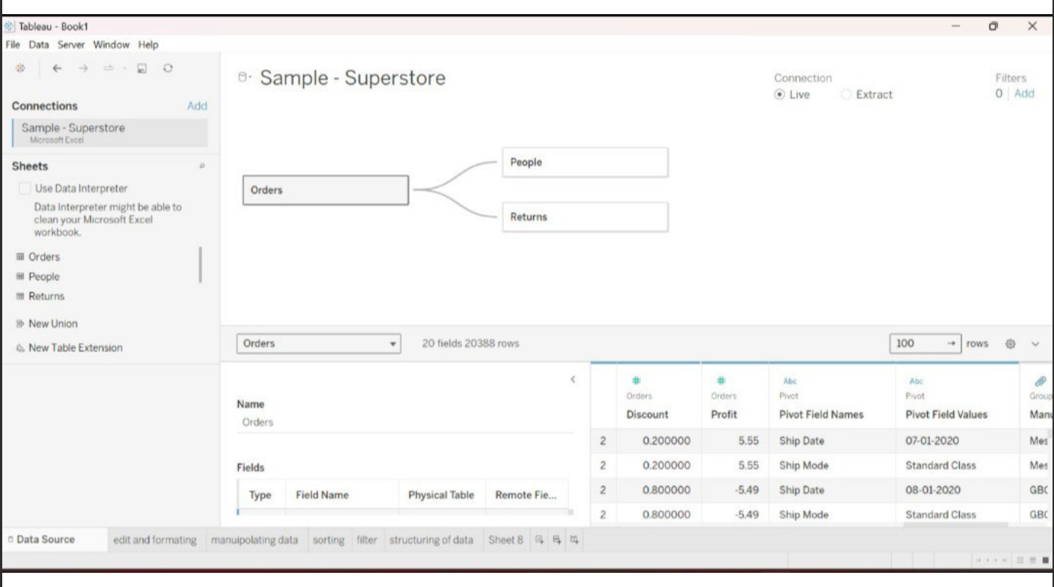

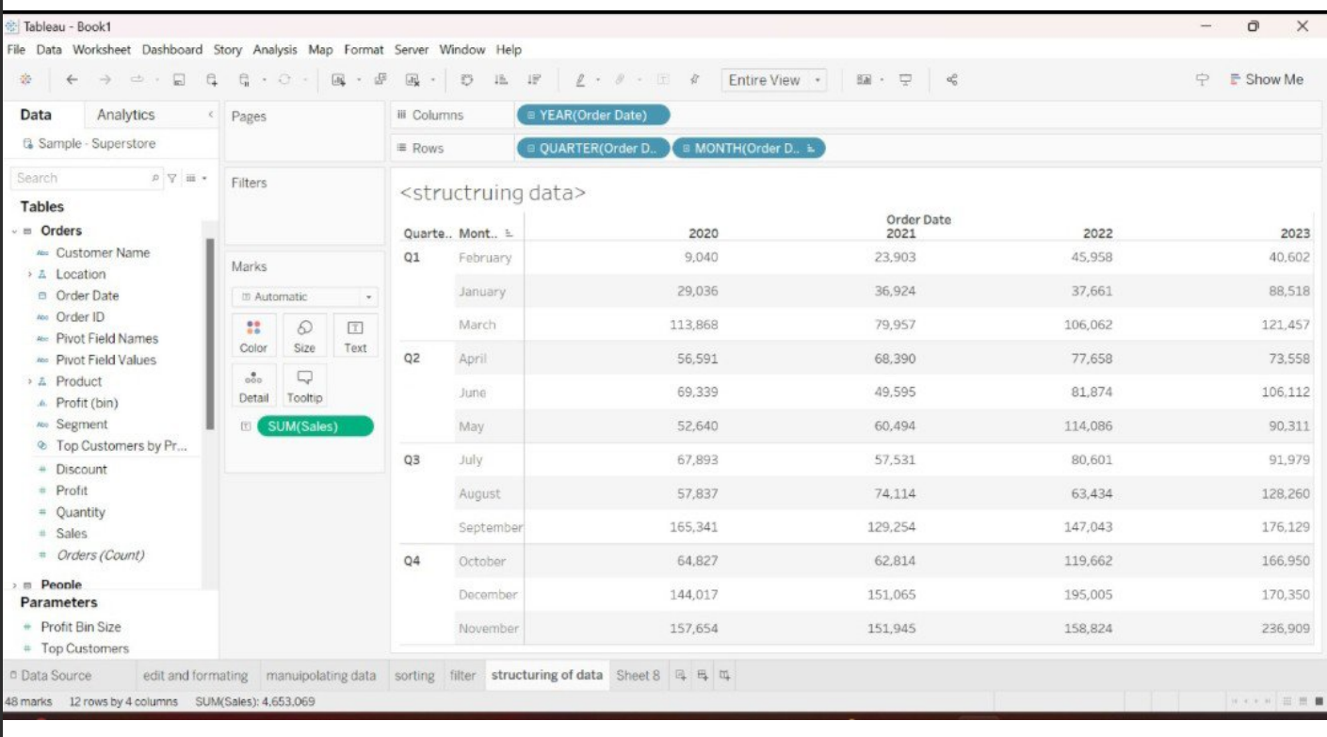

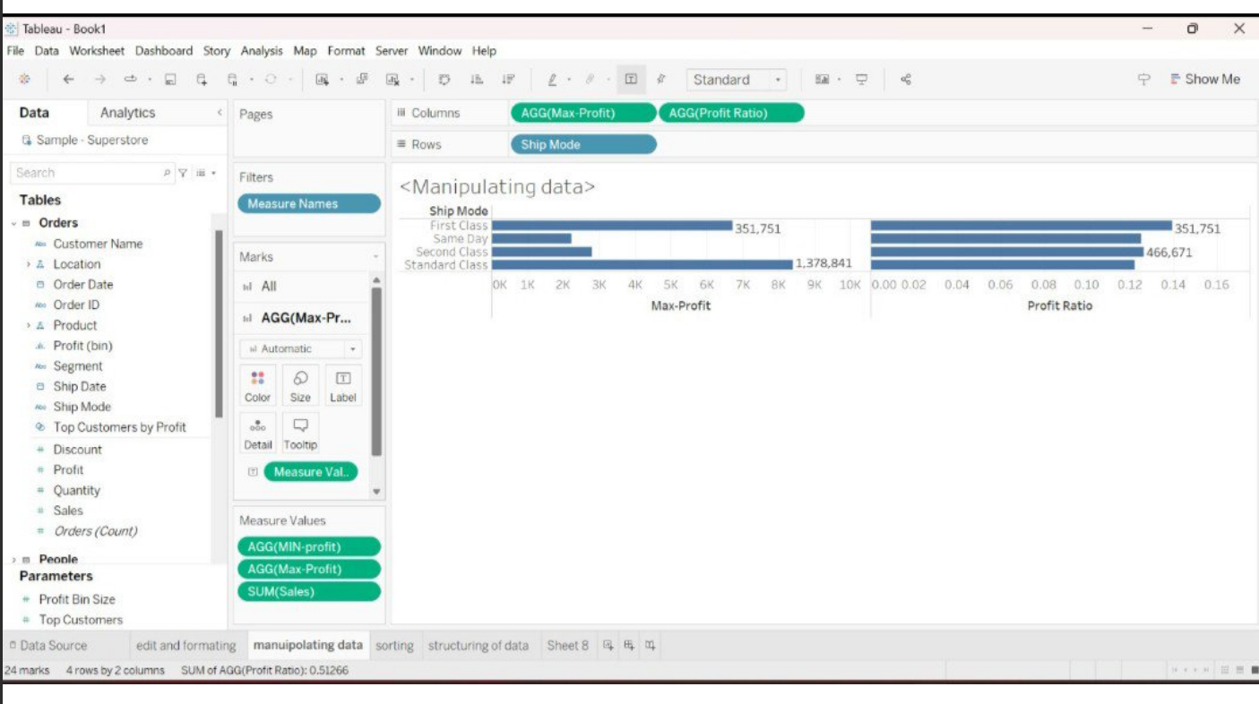

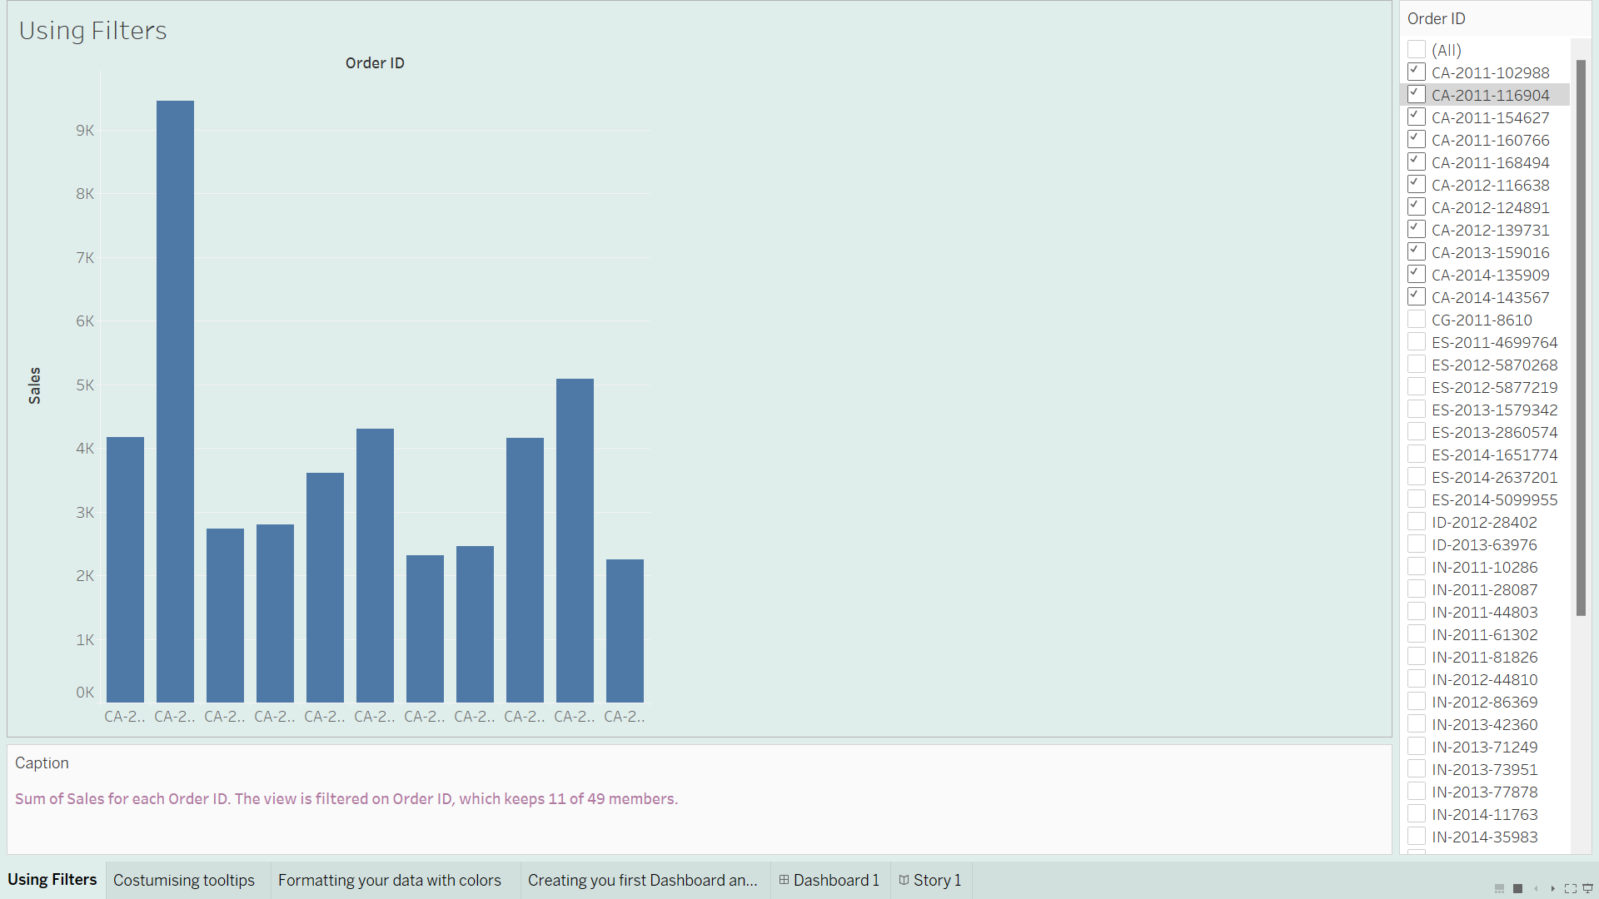

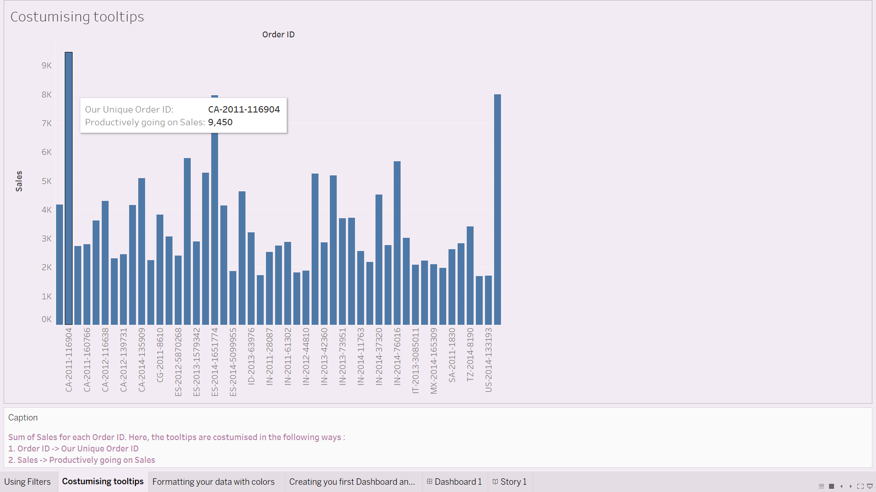

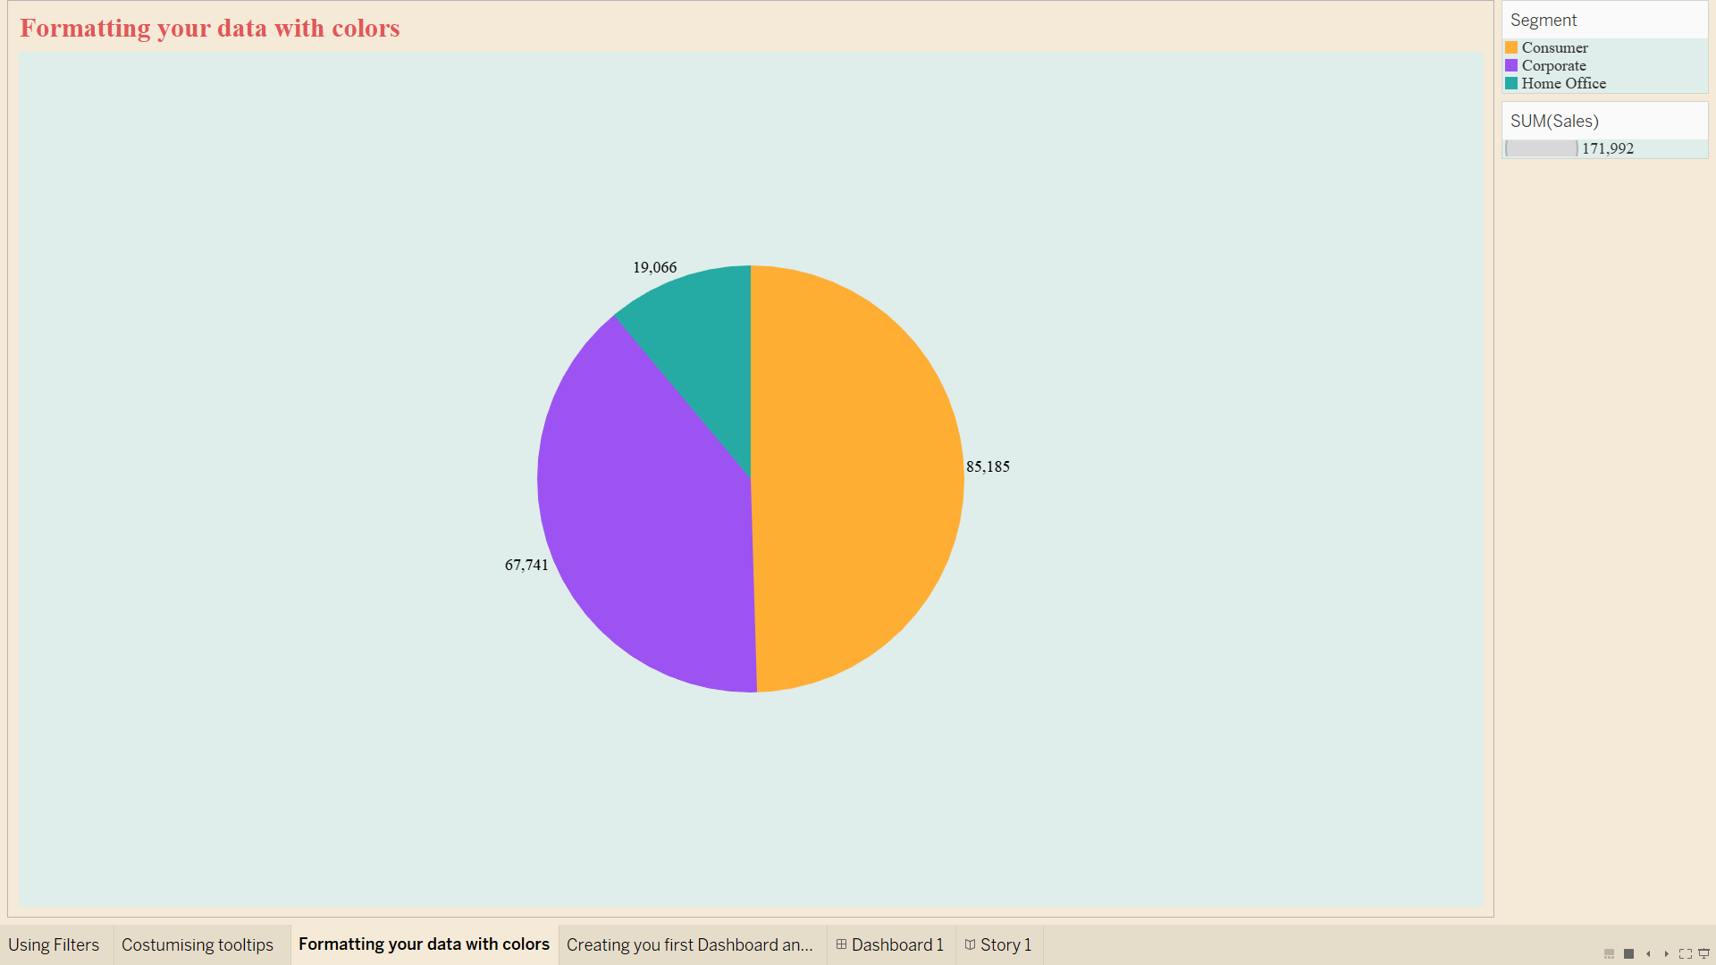

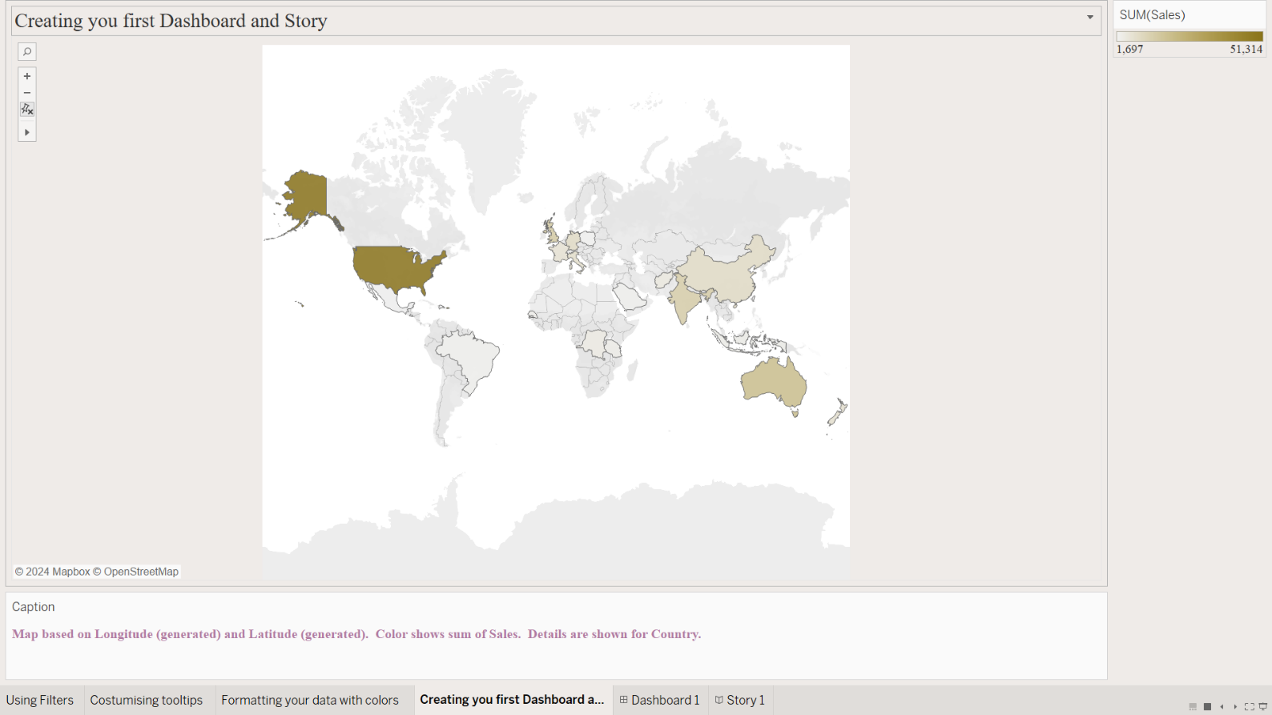

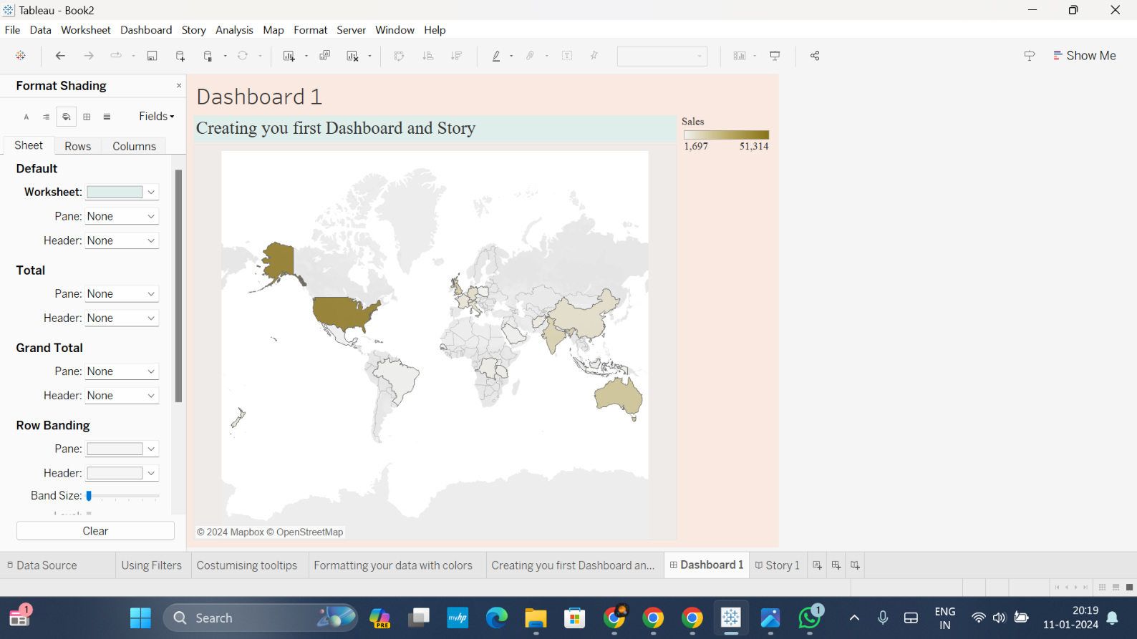

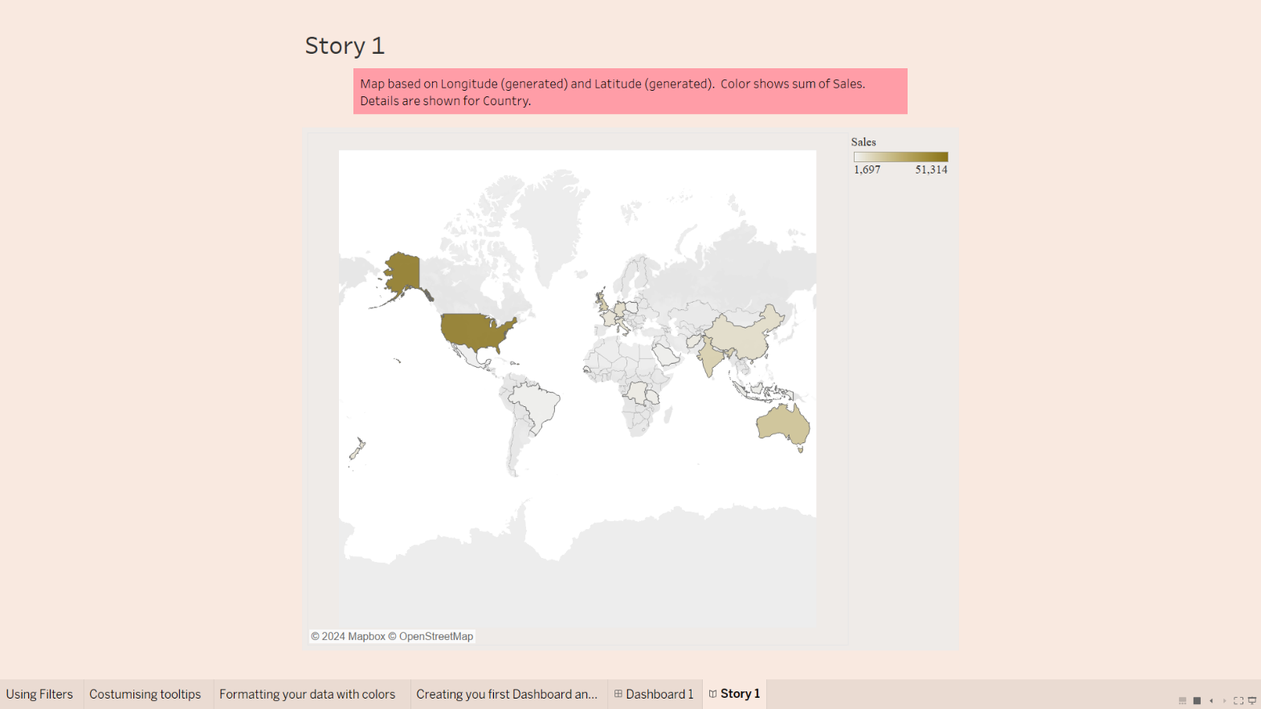

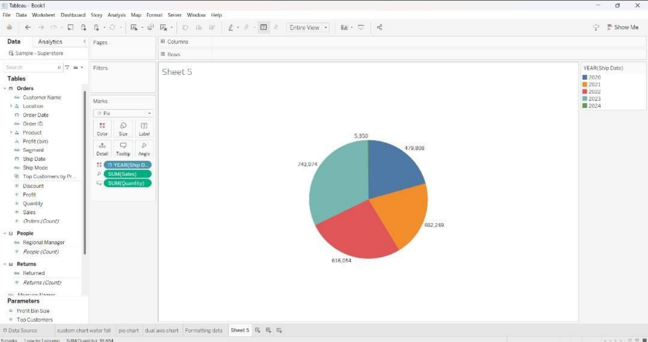

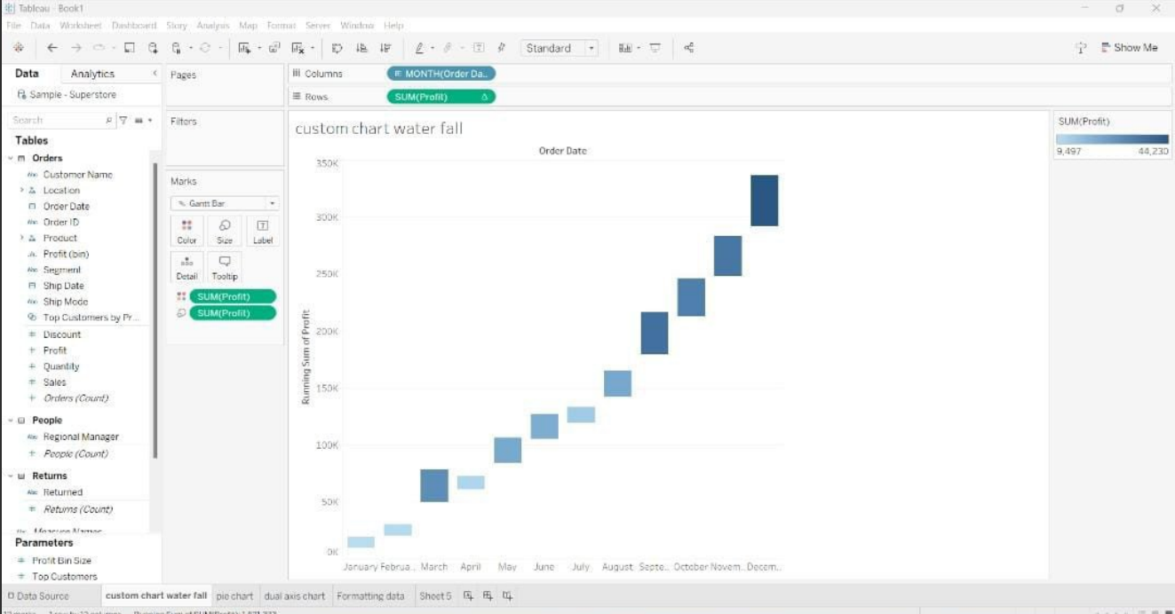

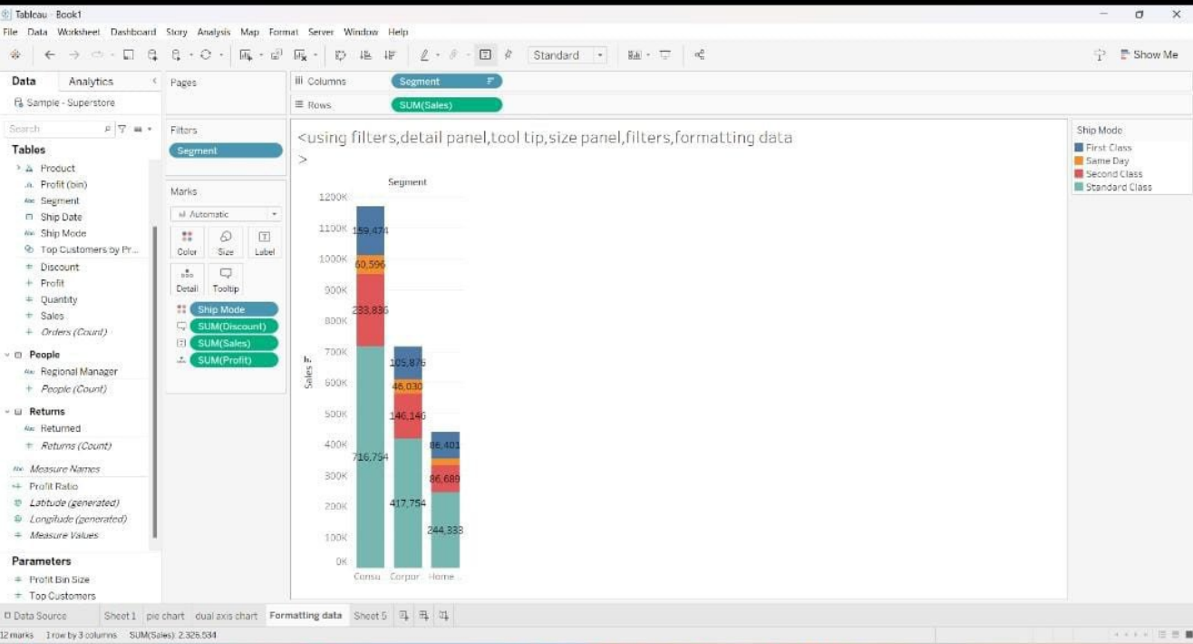

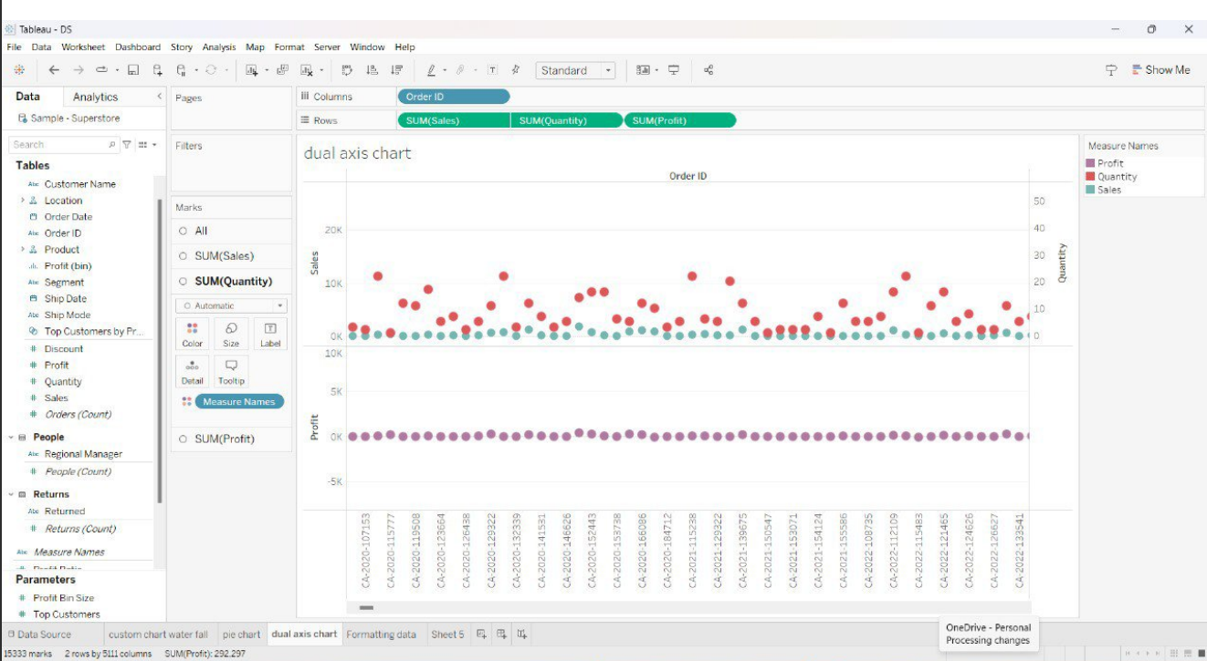

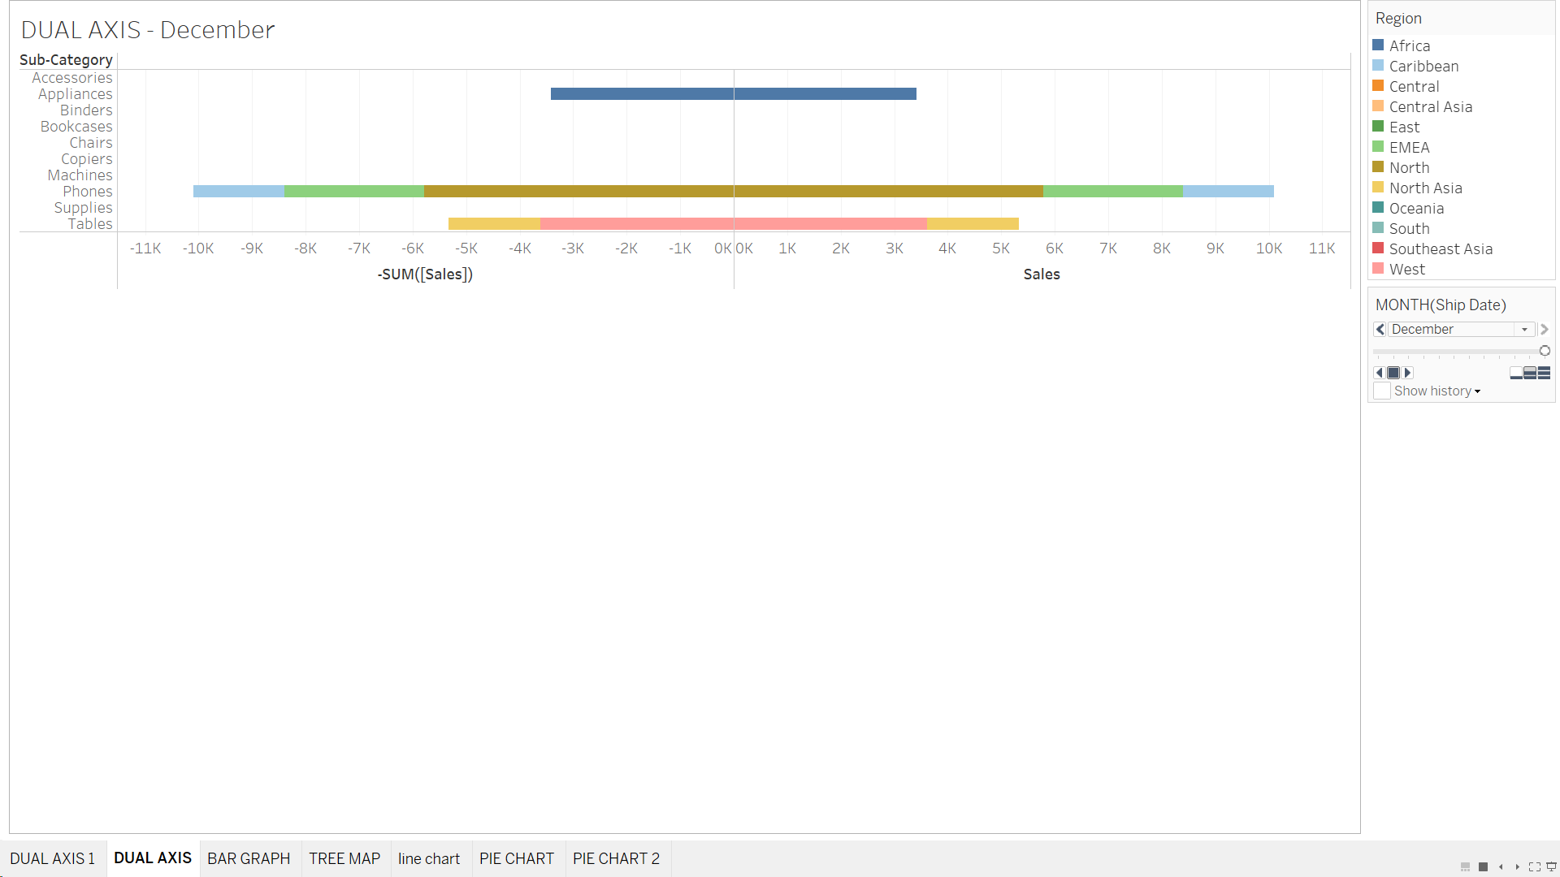

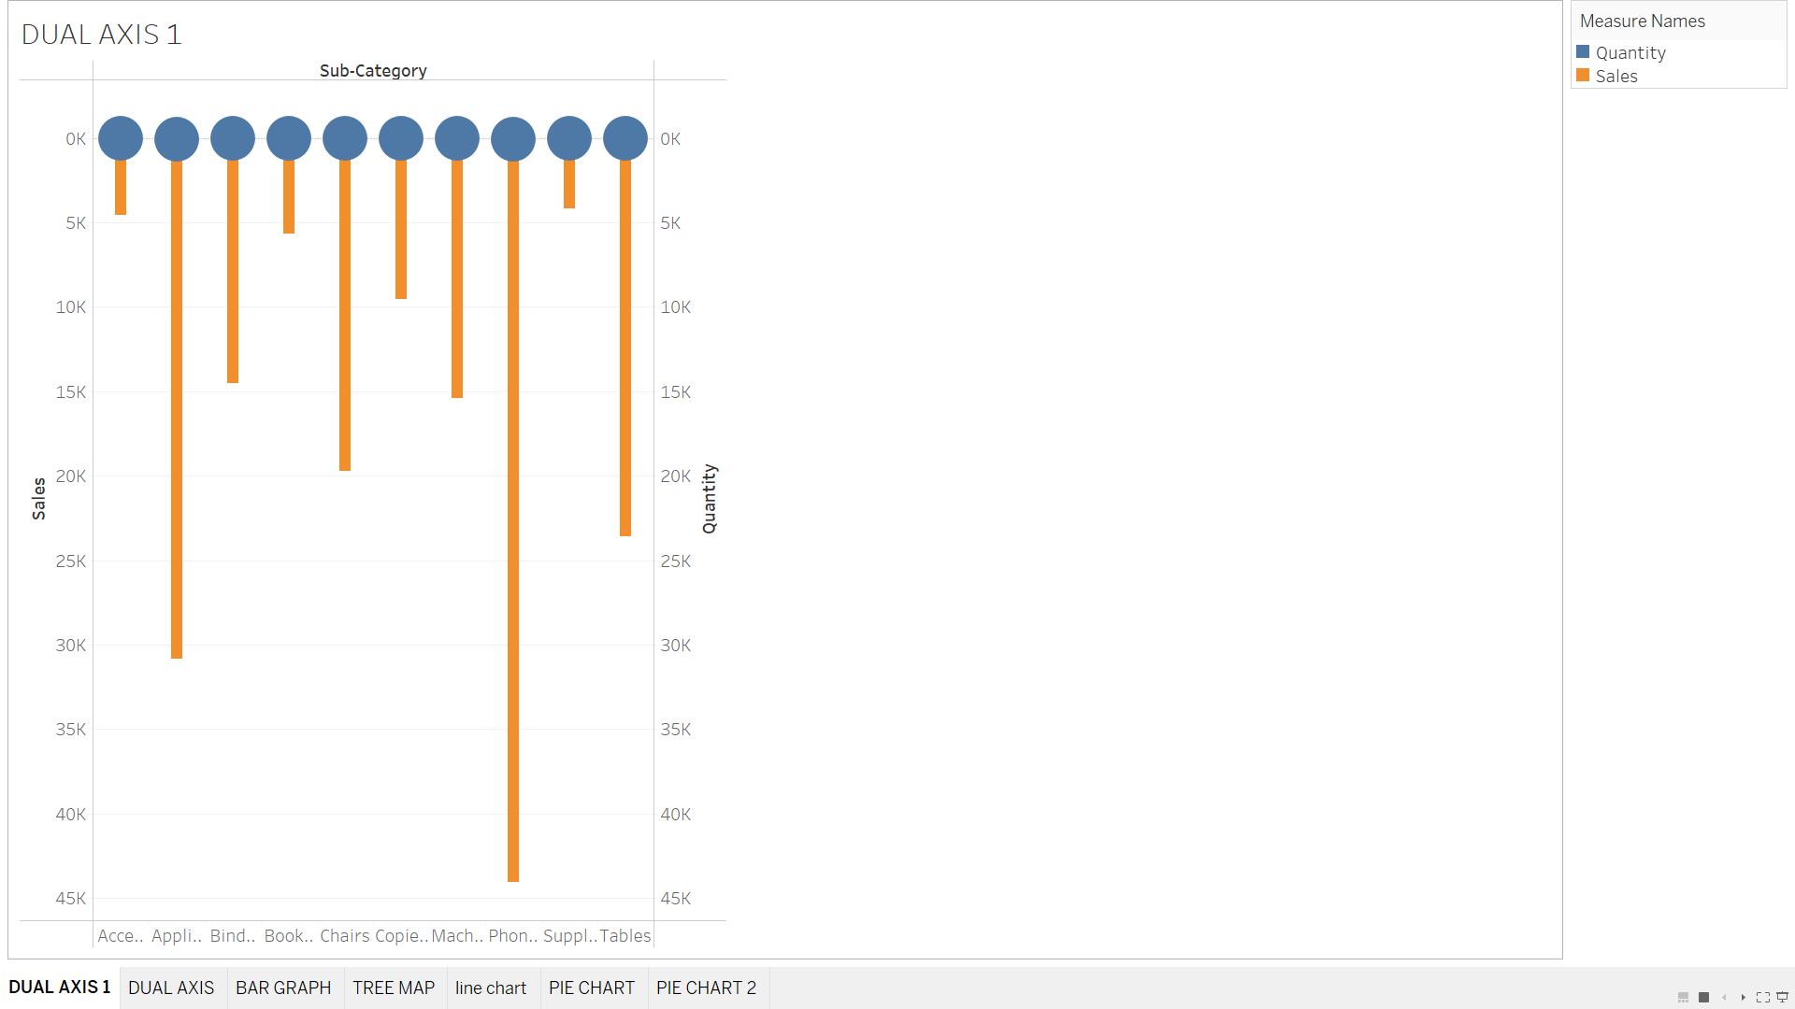

**POWER BI**

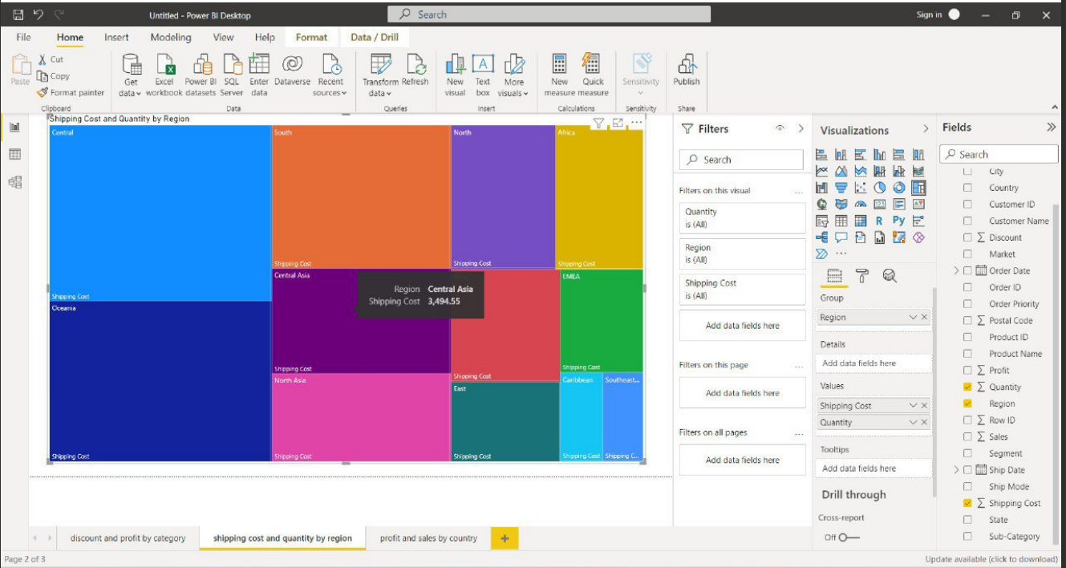

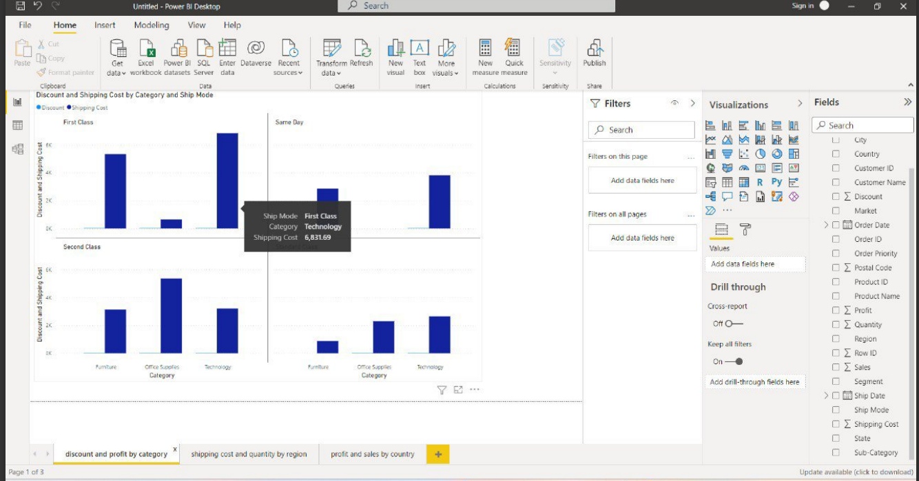

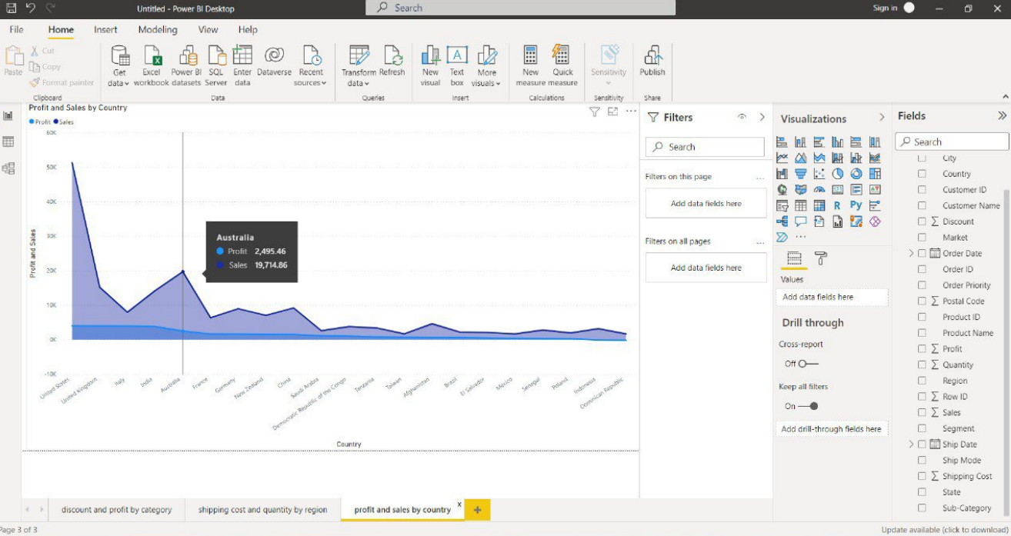

**LOOKER STUDIO**

